AIR FORCE ROTC

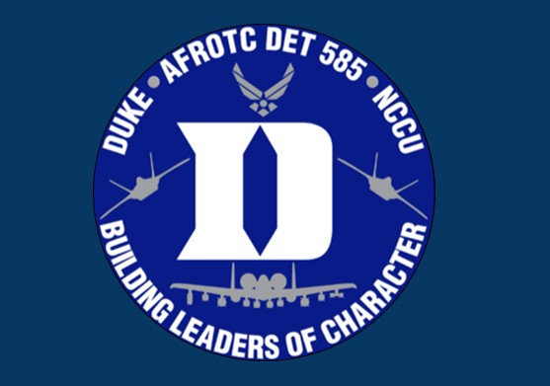

DETACHMENT 585
DUKE UNIVERSITY & NORTH CAROLINA CENTRAL UNIVERSITY

919-660-1869
afrotc.duke.edu det585@duke.edu
310 Trent Drive, Durham, NC, 27708

WELCOME LETTER
Welcome to Air Force ROTC! This packet is designed to provide you with a basic overview of the AFROTC program at Detachment 585. ROTC is a professionally and personally rewarding program that involves a significant amount of dedication. Please familiarize yourself with the contents of this packet prior to our first session. If you have any questions about anything mentioned here, feel free to reach out to General Military Cadet Advisor (GMCA).

The Air Force ROTC program at Duke and NCCU consists of four years of instruction. The first two years, known as the GMC (General Military Cadet) program, involve learning about the Air Force and Space Force. Cadets will take courses and receive instruction on the basics of Air Force and Space Force life, learn about drill and marching, and understand how to act as effective followers. After the AS100 (Freshman) year, cadets will transition to the AS200 (Sophomore) year, in which they will begin to take on leadership roles in preparation for Field Training (FT).
Field Training consists of 13 days of training during the summer between AS200 and AS300 years. Cadets who successfully complete FT will return to the Detachment as members of the POC (Professional Officer Course). During the last two years of ROTC, POC will be expected to take on significant leadership roles within the Detachment, and will serve as leaders and mentors to GMC cadets.
The ROTC program allows college students to gain substantial experience in leadership and a basic introduction to life in the Air Force and Space Force. Successful completion of the program will result in commissioning as a Second Lieutenant into the world’s greatest Air Force or Space Force. By joining Detachment 585, you are entering a journey of professional and personal development that will impact your college career and future life.

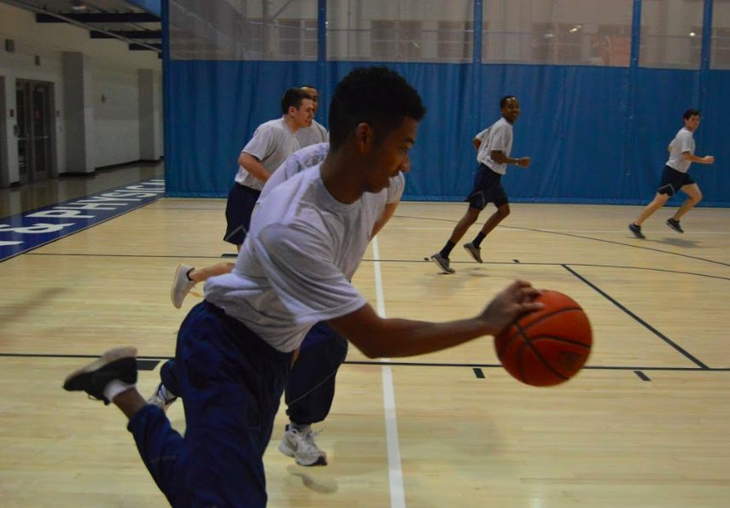
For Physical Training (PT)

- Mandatory Items:
  - If provided, wear the full PT jacket and running pants
  - If provided, wear the PT shirt tucked into the shorts
  - White or Black socks (small logo allowed)
  - Athletic shoes (any color permitted)
  - Athletic undergarments (sports bras, compression shorts, undershirts)
- Optional Items:
  - Water Bottle
  - Blue or Black cold weather gear (gloves, scarf, earmuffs, weather cap)
  - White, black or light gray form fitting undershirts
  - Short, mid and full-length solid black
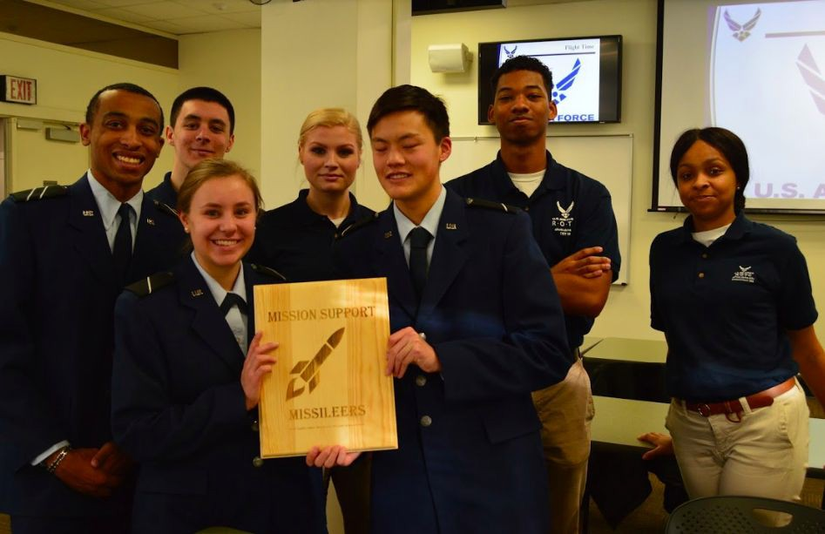
  - white or dark blue form fitting sportswear may be worn under the PTG shorts

For Lead Lab (LLAB) & AS Class

- Detachment Polo
- Khaki pants
- Conservative black or brown belt
- Black or brown dress shoes
- White v-neck undershirt (may be required depending on your flight’s standardization)
- Conservative jacket

During training time cadets are expected to be “locked on.” This means you will adhere to a strict set of rules governing your speech and behavior. These rules are referred to as “Customs and Courtesies.” We practice Customs and Courtesies to maintain military discipline and teach cadets to show proper respect to those above and below them in rank.

Greetings
Greetings are important to cadet life. You will greet cadre, civilian staff, and guest speakers with the proper greeting of the day when passing in and around campus, or when reporting in. These greetings correspond to the time of day and will also be used at the start of official emails.
  - “Good Morning Capt Snuffy:” 0000-1159 (12:00am - 11:59am)
  - “Good Afternoon Capt Snuffy:” 1200-1659 (12:00pm - 4:59pm)
  - “Good Evening Capt Snuffy:” 1700-2359 (5:00pm - 11:59pm)

7+1 Basic Commands
Unless prompted to do otherwise, GMC will respond to any POC or cadre questions with the following statements:
  - “Yes, Sir (Ma’am).”
  - “No, Sir (Ma’am).”
  - “No excuse, Sir (Ma’am).”
  - “Sir (Ma’am), I do not know.”
  - “Sir (Ma’am), I do not understand.”
  - “Sir (Ma’am), may I make a statement?” (not necessary when responding to a direct question)
  - “Sir (Ma’am), may I ask a question?” (not necessary when you are called upon)
  - To excuse yourself when passing an individual or through a group of individuals, politely state, “Sir (Ma’am), Pardon me please.”

Raising hands
To ask a question or make a statement, raise your right arm straight upward, bicep pressed against your right ear, and your hand cuffed. Ask to make a statement or to ask a question utilizing the 7+1 and wait until you are acknowledged.

Sitting at attention
Sit on the front six inches of your chair, back straight, hands cuffed on top of your knees. Your eyes will be caged, looking forward slightly above the horizon, and not wandering. At the command of “EYES” the proper response is call “POST,” uncage your eyes and focus on whoever called “EYES.” Similarly, at the command of “EARS” the proper response is to call “OPEN,” cease speaking and focus your attention on whoever called “EARS.”

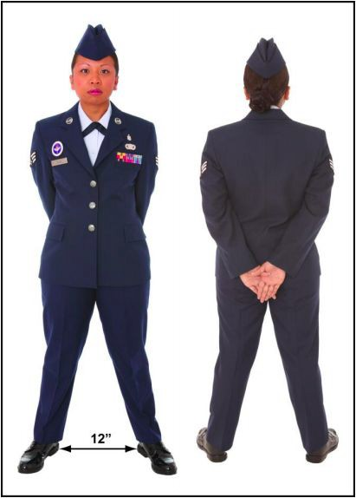
Standing at parade rest
At the command of “parade rest” cadets will assume this position. Feet are shoulder width apart. Hands are bladed and placed behind the small of the back with the right hand above the left, thumbs interlaced with right over left. Your middle fingers should align so that your hands form a “V” shape. There will be no “windows” or gaps between the bicep and/or forearm and the side of the body.

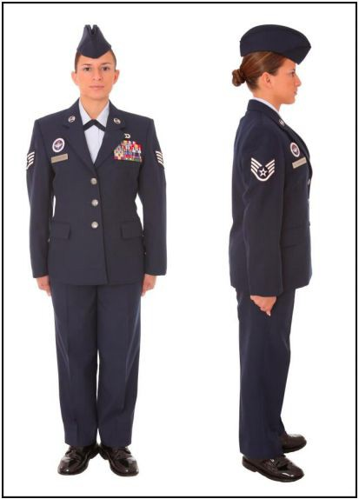
Standing at attention

Calling the room

Standing at parade rest

Standing at attention
Place your feet at a 45 degree angle & heels touching, arms straight & pressed to your sides. Cuff your hands with the thumb aligning with the seams of your pants. Straighten your thorax and press your shoulders
up-back-down. Unless told otherwise, cadets will come to the position of attention when spoken to directly by POC or cadre. Cadets should also maintain caged eyes unless told otherwise.

Whenever an officer of higher rank than those within a room enters or leaves, cadets will “call the room” to attention. Upon hearing the command “room standby,” cadets will cease other activities and stand at parade rest. “Area standby” may be used outdoors. Upon hearing “[room/area] attention (Phonetically: “Tench Hut!”)”, cadets will move to the position of attention. The officer, after entering the room and giving any instructions, will exit with the command “carry on.” Cadets will then respond in unison with “carry on, [Sir/Ma’am]” and resume prior activities. If the highest ranking officer enters or leaves a room/area unexpectedly, the command “[room/area] attention” will be called without prior standby.

Classroom/LLAB Starting Procedures
At the beginning of an academic session, the class leader will call the class to attention and say, “ Class is prepared for instruction.” LLAB will begin with accountability check with everyone sitting at attention.

Saluting
A traditional form of greeting exchanged between members of the armed forces. This is perhaps the most fundamental of the Customs and Courtesies.
- How-To: A salute is rendered from the position of attention when not walking. Cadets will blade their right hand and raise it just above eye level. The tip of the right middle finger should be approximately at the rightmost edge of the right eyebrow. If wearing glasses or a brimmed-hat, the right middle finger should be brought approximately to the rightmost edge of the glasses or brim, whichever is highest. The right arm should be parallel with the ground and the hand angled such that the thumb cannot be seen from the front. Note: salutes are not rendered indoors except for ceremonial procedures, such as reporting in.
- Saluting Senior Military Officers: When GMC cadets are within 6 paces of an officer or POC cadet, they will render a salute. The officer or POC cadet will return the salute, and only when he or she has lowered their salute may the GMC cadet then lower their own. A salute is often accompanied by the greeting of the day.
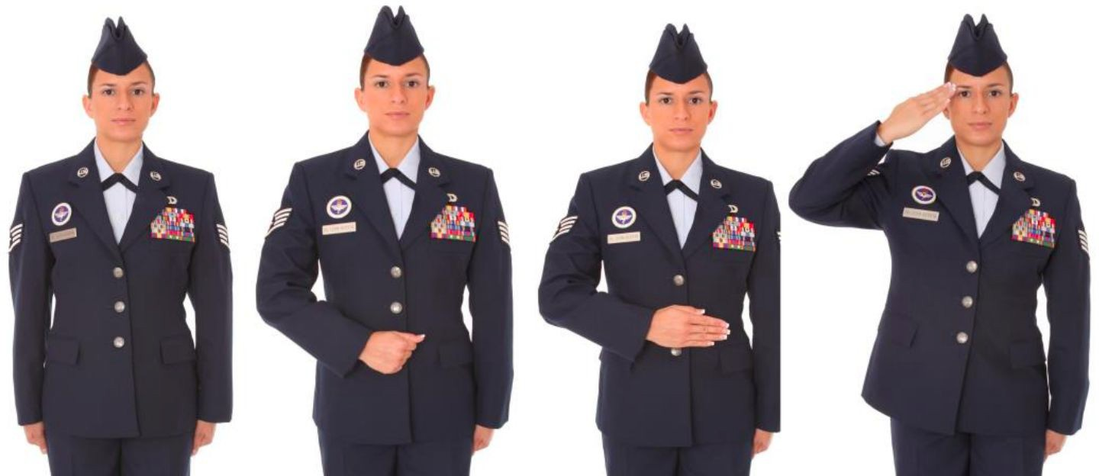
- Saluting the U.S. Flag: Cadets in uniform must face and salute the flag while it is raised and lowered. When the national anthem or the bugle call “To the Colors” are played, cadets not in formation will stand and face the flag and hold a salute until the song is ended.

Reporting in procedures
The cadet will knock once, wait outside to be told to enter, then enter taking the most direct path and stopping 3 paces in front of and centered on the superior’s desk.
- The cadet will render a salute with the appropriate greeting. The cadet will then state his/her name followed by “reports as ordered.”
  - Example: *Salute* “Good afternoon Capt Snuffy, Cadet Snuffy reports as ordered.”
- The superior will return the salute and may instruct the cadet to sit and/or be at ease. Unless told to do otherwise, the cadet will remain at the position of attention.
- Once the conversation has come to an end the cadet will ask, “Will that be all, Sir/Ma’am?”
- If the superior says yes, the cadet will take one step backward, salute and give the greeting of the day. After the superior returns the salute, the cadet will exit along the most direct path.

Policies on email etiquette and responsiveness:
- Rules for Air Force email format and etiquette can be found in the Tongue and Quill, page 134.
- All cadets will respond to communications from cadre within 24 hours. GMC will likewise respond to POC communications within 24 hours.
- Emails will begin with a greeting and end with “Very Respectfully, (Cadet Name)”. This can be abbreviated to “V/R”.
- Cadets should utilize a professional email signature that clearly states name, rank, and contact information.

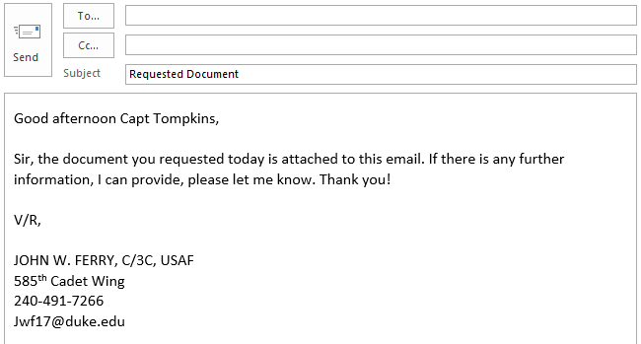

- It is recommended that you check your email every night to stay current on ROTC events and information. Respond to all emails in a timely manner and within 24 hours. You should acknowledge all emails from Cadre regarding any task you are to complete.
- Whenever sending or replying to an email:
  - Do have a clear subject line.
  - Don’t forget your signature block.
  - Be sure to use a professional salutation.
  - Don’t use humor, sarcasm or all caps.
  - Don’t use fancy letters or colors.
  - Be sure to proofread your message before sending.
  - Don’t ever assume the recipient knows what you are talking about.

Male Hair Standards
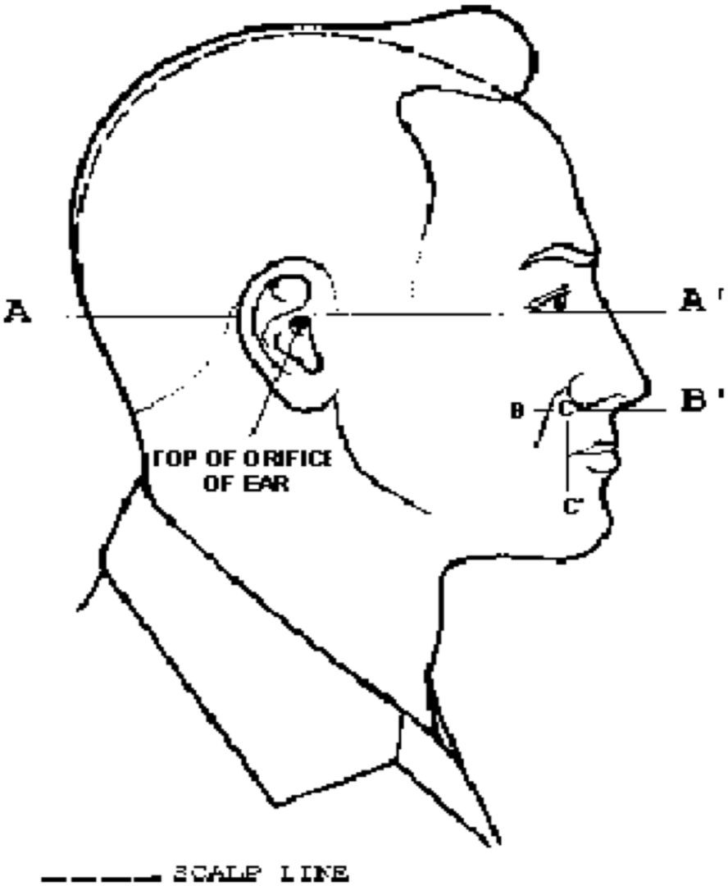
- Hair
  - Clean, well groomed, “natural” color
  - Hair will not exceed 2 inch in bulk & 1/4 inch at termination
  - Hair will not touch the ears
  - Hair will not protrude under front band of headgear
  - Sideburns will not exceed the bottom of the orifice of the ear opening and will end in a horizontal line
- Facial Hair
  - Beards are not allowed
  - Mustaches will be conservative and will not extend downward beyond the lip line of the upper lip
  - Cannot extend sideways beyond a vertical line drawn upward from both corners of the mouth

Female Hair Standards
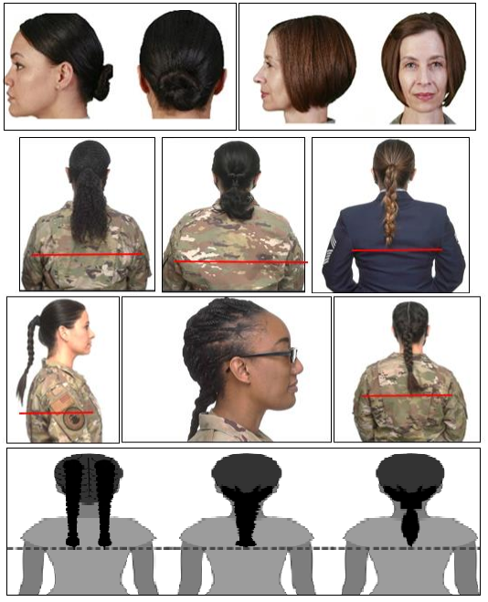
    - No minimum hair length
    - Maximum bulk of 4 inches from scalp and allows proper wear of headgear
      - Hair will end above the bottom edge of collar and will not extend below an invisible line drawn parallel to the ground, both front to back and side to side unless worn in authorized ponytail or long braid(s)
      - PTU Exception: long hair will be secured but may have loose ends and may extend below the bottom edge of the collar.
    - Hair accessories, will be black or match hair color
    - All locs, braids, and twists, when worn will be of uniform dimension, no wider than one inch, with natural spacing between the locs, braids, or twists and must be tightly interwoven to present a neat, professional and well-groomed appearance. When worn, multiple locs, braids, or twists shall be of uniform dimension, small in diameter (approx. 1⁄4 inches), show no more than 1⁄4 inch of scalp between the locs, braids or twists and must be tightly fused/interwoven to present a neat, professional appearance.

Tattoos and Body Markings
- A tattoo is defined as a picture, design, or marking made on the skin or other areas of the body by staining it with an indelible dye, or by any other method, including pictures, designs, or markings only detectible or visible under certain conditions (such as ultraviolet or invisible ink tattoos). A brand is defined as a picture, design, or other marking that is burned into the skin or other areas of the body. Body markings are pictures, designs, or other markings as a result of using means other than burning to permanently scar or mark the skin.
- Tattoos/brands/body markings will not be on the hands (except one ring tattoo on one finger on one hand), head, neck (anything visible above the open collar uniform), face, tongue, lips, eyes, and scalp. Tattoos/brands/body markings anywhere on the body that are indecent, commonly associated with gangs, extremist, and supremacist organizations, or that advocate sexual, racial, ethnic, or religious discrimination are prohibited in and out of uniform.
- Tattoos are authorized on the chest and back (below the open collar uniform), arms, legs, and a ring tattoo on one finger on one hand. Ring tattoos are limited to a single band of no more than 3/8 of an inch in width, below the knuckle and above the finger joint (portion closest to the palm). Chest and back tattoos will not be visible through any uniform combination(s) or visible while wearing an open collar uniform. There are no size or placement limitations on tattoos as long as they are in accordance with this publication.

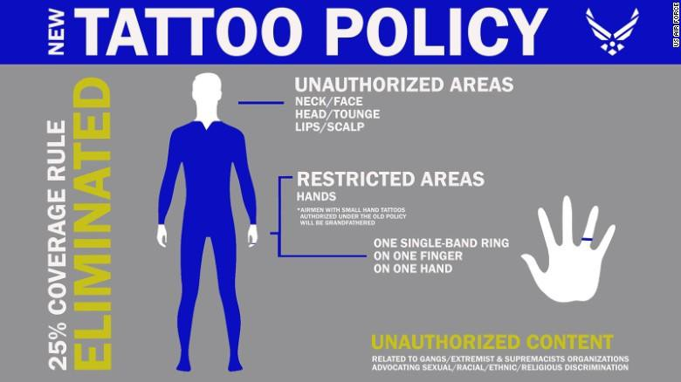

  - All AFROTC cadets must report any involvement with:
REPORTING CIVIL AND MEDICAL INVOLVEMENTS
    - Law enforcement
    - School officials
    - Military authorities
    - Any civil authorities
  - Involvements must be reported within 72 hours of the incident.
    - Involvements can include receiving a moving violation or being charged by a civil, military or University authority regardless of seeming insignificance or disposition. Even if it is a warning, the involvement must be reported and all involvement must be reported, even if a finding of “not guilty” was rendered. If the National Agency Check required for commissioning finds an unreported involvement, charges of breach of contract may result in removal from the AFROTC program. Parking tickets do not need to be reported.
  - Follow up actions will be discussed with the cadet by the cadre after submission of the report.
  - Due to the stringent physical qualification necessary to enter the Air Force and certain Air Force career fields, cadets must also report any medical changes that occur, no matter how minor. The following are examples (not all inclusive) of a medical status change: any medical diagnosis, any surgery, breaking or fracturing bones, allergies, prolonged illness, prescribed medications, severe sprains or muscle pulls, and pregnancy. Failure to disclose a change to your medical status could result in your removal from the program.
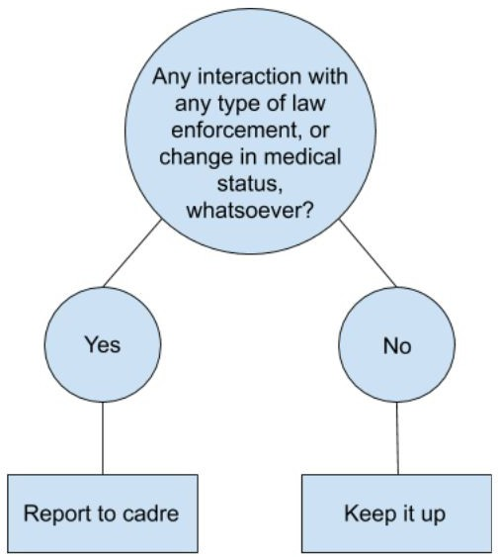

What is AFROTC?
Air Force Reserve Officer Training Corps (AFROTC) is one of the three primary commissioning sources into the USAF. It is typically a four-year program preparing cadets to become commissioned USAF officers.

Will I have to attend basic training?
No, you will not attend traditional Basic Military Training like enlisted personnel. However, all cadets are required to attend AFROTC Field Training during the summer between their Sophomore and Junior years. Field Training is a 13 day program at Maxwell Air Force Base in Montgomery, AL and attendance is required to be commissioned in the USAF.

- What happens after I graduate from college? You will commission into the USAF as a Second Lieutenant.

How can I receive a scholarship?
There are opportunities to compete for scholarships from the Air Force while in college. Not every cadet is on a scholarship. AFROTC scholarships are offered based on grades, SAT/ACT scores, physical fitness, overall performance, choice of major, and commander’s recommendation.

What are the service requirements?
There is a 4-year active duty service requirement for non-rated positions, but there are longer service requirements for rated positions. Rated positions include Pilot, RPA Pilot, and Air Battle Manager.

Will I have to buy uniforms?
All uniforms and other required equipment are issued free-of-charge through the detachment. However, upon commissioning as an officer at the end of college, cadets must buy their own uniforms. Uniforms worn throughout ROTC may be purchased at half-price.

When will I wear my uniform?
Uniforms are worn from 0800-1730 for days on which cadets have AS class or LLAB. Physical Training Gear (PTGs) are worn for PT, but cadets are not permitted to wear PTGs throughout the day.

Are there fitness requirements?
Each cadet is required to attend all scheduled physical training (PT) sessions at Duke University and North Carolina Central University. Transportation is organized among cadets in the detachment. Physical training is designed to help you meet Air Force physical standards and maintain an active and healthy lifestyle through college. The Air Force fitness assessment (FA) consists of a waist measurement, weight & height measurement, one minute of
push-ups, one minute of sit‐ups, and a 1.5 mile run.

- What is leadership laboratory (LLAB)? Leadership Lab is mandatory for all AFROTC cadets. LLABs include a study of Air Force customs and courtesies, drill and ceremonies, and military commands. LLAB also includes studying the environment of an Air Force officer and learning about areas of opportunity available to officers. During junior and senior years (AS300 and AS400), LLAB consists of activities classified as leadership and management experiences. LLAB also includes interviews, guidance, and information that will increase the understanding, motivation, and performance of cadets.

Can I participate in AFROTC if I am a member of other organizations?
Yes, you can participate in almost any student organization that you are interested in. AFROTC is a notable time commitment, but cadets are able to participate in any other extracurricular as long as there are no scheduling conflicts.

- Does joining AFROTC mandate I commission? Cadets are not under obligation to join the military until they sign a contract with the USAF. After a contract is signed (typically upon receiving a scholarship or at the start of junior year), cadets are obligated to serve in the Air Force.

What activities are available to cadets beyond training?
There are a plethora of activities available to cadets who actively participate in the program. Cadets may volunteer for color guard events, join Arnold Air Society, attend USAF base visits and engage in summer Professional Development Training opportunities.

How does transportation work in our detachment?
The transportation plan is organized by cadets early in the semester. Duke cadets commute to NCCU for NCCU events, and NCCU cadets commute to Duke.

- Can I still join AFROTC after freshman year? Yes, you can. The program can be accelerated or extended depending on the circumstances. Please reach out to the AFROTC cadre member for assistance.

How does AFROTC affect prior service members?
Many enlisted members choose ROTC as a route to commissioning as an officer. Please reach out to the AFROTC cadre member for assistance.

What do we learn in class?
AS classes are run by the cadre, who are active duty officers in the USAF as well as professors or assistant professors of Aerospace Studies. Under their instruction, cadets will learn the history, procedures, and valuable leadership lessons of the Air Force.

How is our detachment structured?
The detachment is formed in a Wing structure, with upperclassmen cadets running the program.
Commissioned Air Force officers serve as cadre, overseeing the operations of the detachment.

I have no prior military experience or my family is non-military, will I fit in?
Yes, many of the cadets in our detachment have no prior military affiliation. The goal of the program is to prepare future officers, regardless of prior experience.

What are the skills I need to succeed?
Time management, a positive attitude and resilience are extremely important. These skills will not only be valuable assets to your officer tenure but also to life beyond the military. The AFROTC program is designed to help cadets build and develop these skills.

- Will I receive graduation credit for AFROTC? Yes, the AFROTC classes and lab will count towards graduation. Classes in the freshman and sophomore years count for half a credit, and classes in the junior and senior years count for one credit. However, at Duke University, no more than 4.0 credits in military science (i.e., courses listed as Military Science, Aerospace Studies, or Naval Science) may count towards graduation. At NCCU, AS classes can be counted up to 18 credits towards graduation.

- How much will AFROTC affect my college life? Your primary obligation is to be a student. Outside of mandatory events, your enjoyment and involvement in the program is contingent on how much effort you put in. There are many optional events, such as Color Guard opportunities and recruiting events, that are both fun to attend and provide valuable experience. However, nothing beyond AS class, LLAB, and PT are mandatory, allowing cadets to spend time pursuing other extracurriculars if they wish.

Helpful Documents
These documents contain information that may be helpful to reference throughout the year. All documents can be found on the cadet wing share drive, or on the internet.
  - Tongue and Quill: This manual contains examples and rules for all forms of Air Force written and spoken communication.
  - Drill and Ceremonies (D&C) Manual: This manual describes the fundamentals of every permitted drill movement.
  - OPLAN: Located on the Cadet Wing Drive, this document provides an overview for the semester, including the current Org Chart, details on every week’s LLAB events, and Duty Descriptions.
  - Group Suspense Tracker: This tracker, located on the Share Drive, will display each suspense assigned throughout the wing. It is divided by flight and will be updated by your flight commander or your POC supervisor.
  - Warrior Knowledge Packet: The Warrior Knowledge Packet will be distributed during the first week of ROTC training. This packet, also located on the drive, will contain information that will be memorized throughout the semester.

Ways to Prepare
  - Physical Training (PT):
    - The Air Force physical fitness test includes pushups, sit-ups, and a 1.5-mile run. The minimum and maximum requirements for each section are below. It is highly recommended that you get into the habit of regular training prior to entering the program.

Males
 | 1.5 Mile Run | Pushups in 1 Minute | Sit-ups in 1 Minute
Maximum | 9:12 | 67 | 58
Minimum | 13:36 | 44 | 42

Females | 1.5 Mile Run | Pushups in 1 Minute | Sit-ups in 1 Minute
Maximum | 10:23 | 47 | 54
Minimum | 16:22 | 18 | 38

  - Warrior Knowledge:
    - As a cadet in AFROTC, you will be responsible for memorizing all of the information contained within the warrior knowledge packet distributed during the first week of training. It is recommended that you begin familiarizing yourself with the Air Force Code of Conduct, Airman’s Creed, and Air Force Song before entering the program (can be found online).

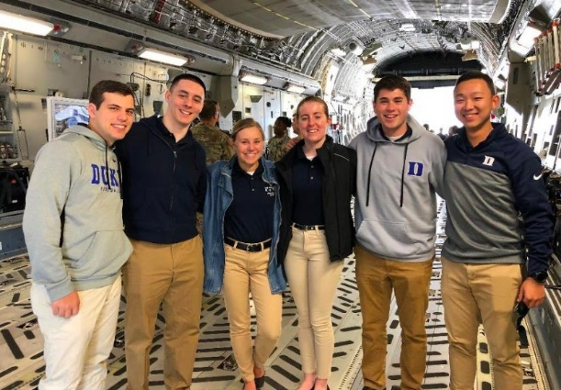
- “Come ready to learn. The AFROTC program assumes no prior military or Air Force knowledge. As long as you are always ready to participate and learn, you will do just fine.” – AS 200, Sophomore
- “Identify your ‘why’ as soon as possible. Ask yourself why are you here and what do you want out of this program. Your ‘why’ is what is going to keep you here and motivated.” – AS 400, Senior
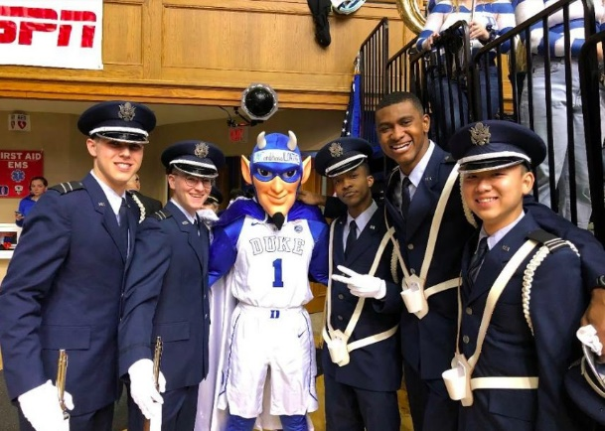
- “Set a high bar for yourself. Push yourself to do more than just what others will accept.” – AS 200, Sophomore
- “Be open to learn and grow in all aspects of life. The program will be hard, but you can make it. Continue to be teachable!” – AS 400, Senior
- “Understand that ROTC is, in some ways, a job. Not everything you do in ROTC will be fun. At first, some things you do may seem to have no purpose. Keep in mind that this program is an investment in you. You’re getting much more out than you’re putting in.” – AS 400, Senior
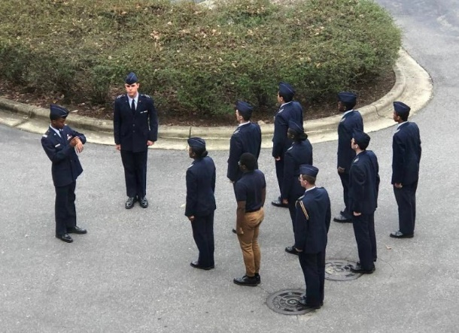
- “Stay ahead so you don’t fall behind.” -AS 200, Sophomore
- “Sleep! Go to bed EARLY” - AS 200, Sophomore
- “Come with an open mind and a willingness to learn and do different things. Not everything is normal or has immediate obvious value, but the experience will leave you a better person on the other side. Know that everyone is here to see you succeed.” – AS 100, Freshman
- “Know that it’s a four-year program – the POC are still learning how to lead too and will not always be perfect. Above all be ok with making mistakes! If you don’t try and fail, you’ll never improve!” -AS 400, Senior

KEY AFROTC LOCATIONS

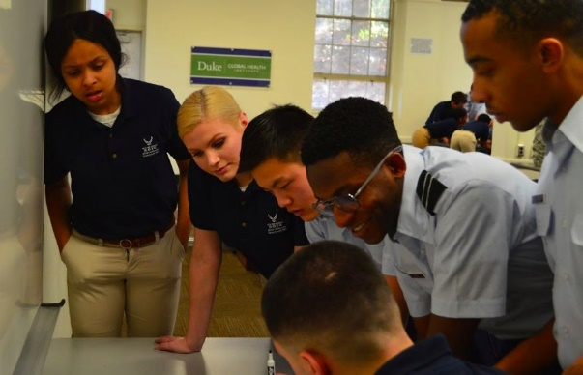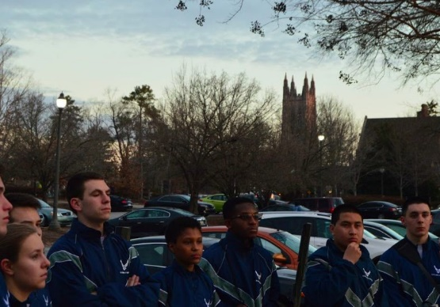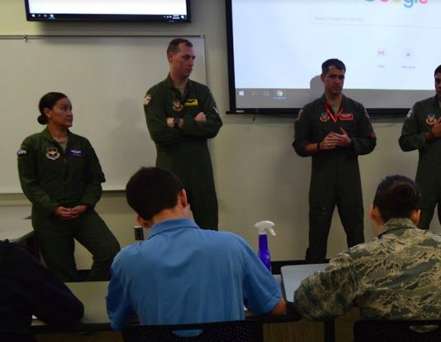

Building: | Campus: | Purpose/Events: | Address:
Trent Hall | Duke (W. Campus) | Detachment (2nd floor) AS Class 200/300/400 | 310 Trent Drive Durham, North Carolina 27710  Parking Deck: 302 Trent Dr, Durham, NC 27705
West Duke 108B | Duke (W. Campus) | AS100 Class | 364 Campus Dr, Durham, NC 27708
Richard White Lecture Hall | Duke (W. Campus) | Leadership Lab (LLAB), Rm 107 | 1308 Campus Dr,  Durham, NC 27705
Morris Williams Track | Duke  (West Campus) | Standard outdoor PT location on Duke’s campus | 81-99 Science Dr,  Durham, NC 27708
Wilson Recreation Center | Duke  (West Campus) | Standard indoor PT location on Duke’s campus | NOTE: Park in same location as Morris William Track
NCCU Track | NCCU | Standard outdoor PT location on NCCU’s campus | 1450 S Alston Ave, Durham, NC 27707
LeRoy T. Walker Physical Education and Recreation Complex | NCCU | Standard indoor PT location on NCCU’s campus | 1450 S Alston Ave, Durham, NC 27707

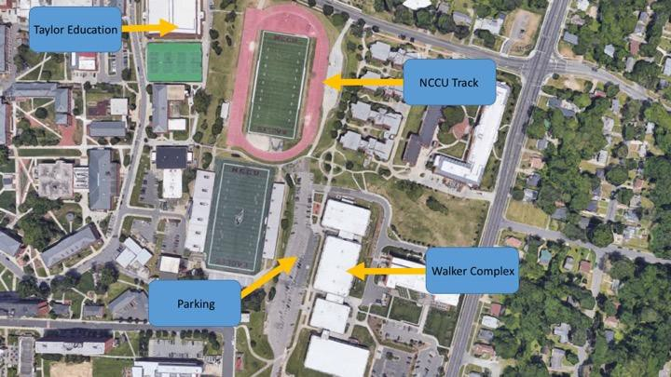
NCCU Locations

Duke Locations
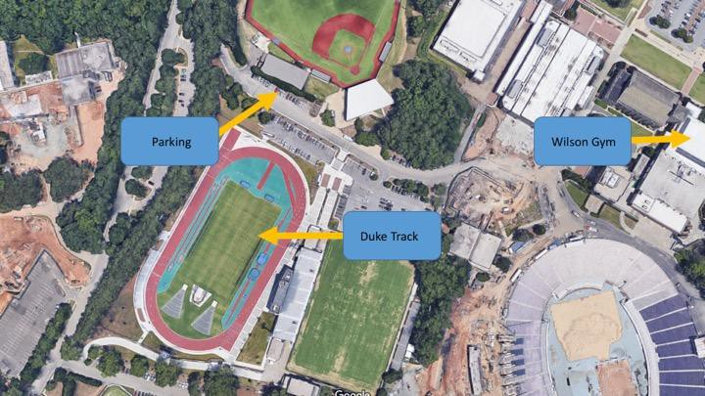

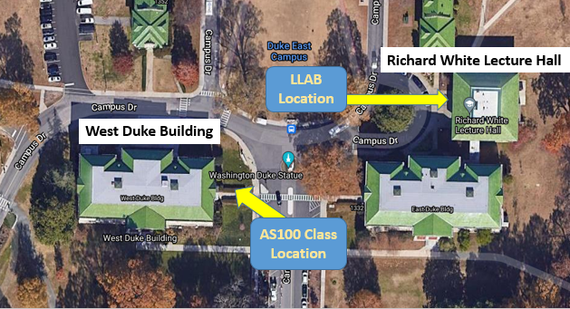

Detachment Location
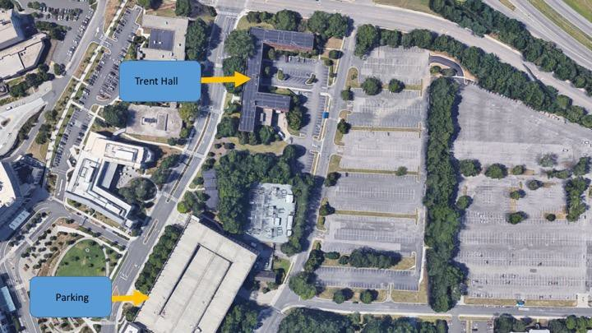

DEE-E-TEE . . .

FIVE-EIGHT-FIVE!

